Step 1: Go to the website of the solar panel location. This can be done by going to https://monitoring.solaredge.com, logging in, and then clicking one of the sites.
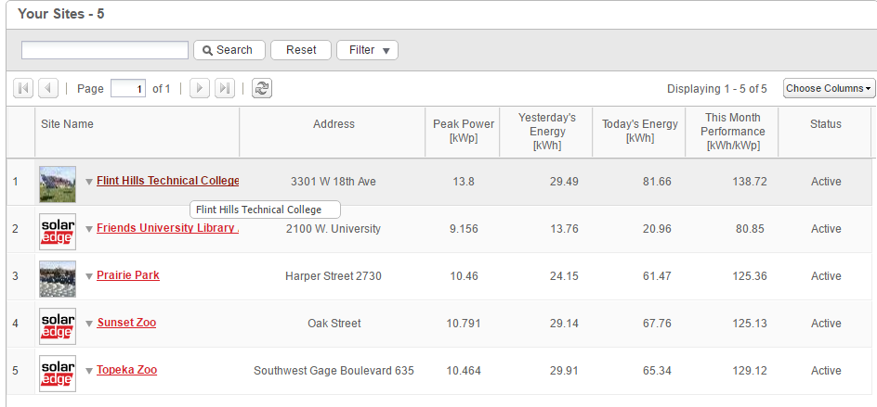
Step 2: At the top, click on the Admin tab and then go to the “Site Details” Tab
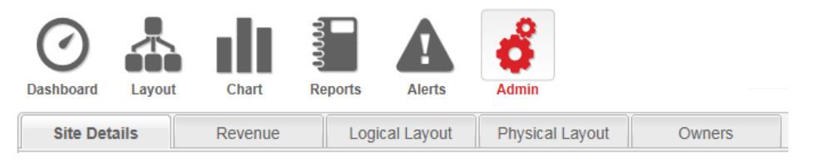
Step 3: Scroll to the bottom of the screen, and note both what location you are working with and what the API Key and System ID are.